**ADBMS Practical**

Practical 8:Database backup and restore

Using Workbench

**1.Backup**

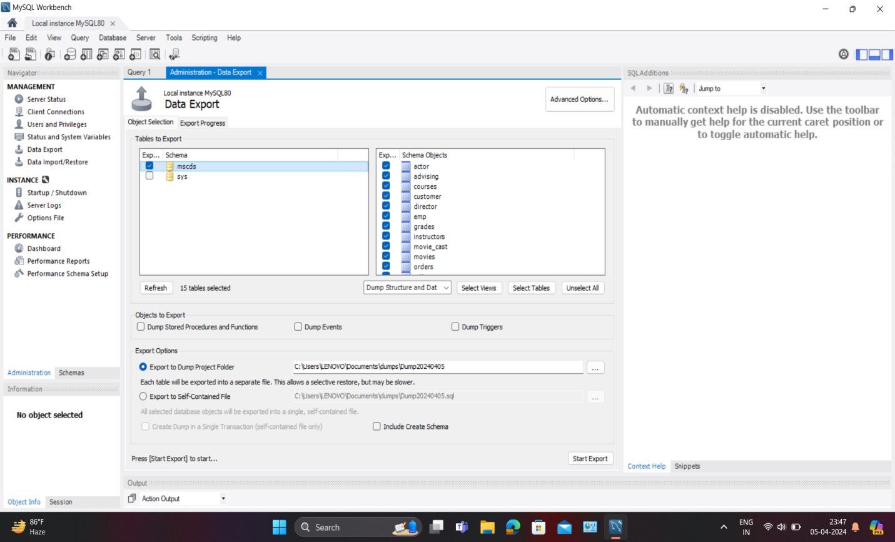

1. **Go to the Administration tab, on the Navigation panel (on the left by default)**
2. **Select Data Export**
3. **From the Data Export tab in the Tables To Export section, select the databases and tables that will be added to the backup file**
4. **From the Export Option section, select the format for the exported data. Either each table will be exported to a separate .sql file, or one common .sql file will be created.**
5. **Press the Export button to create a backup file.**

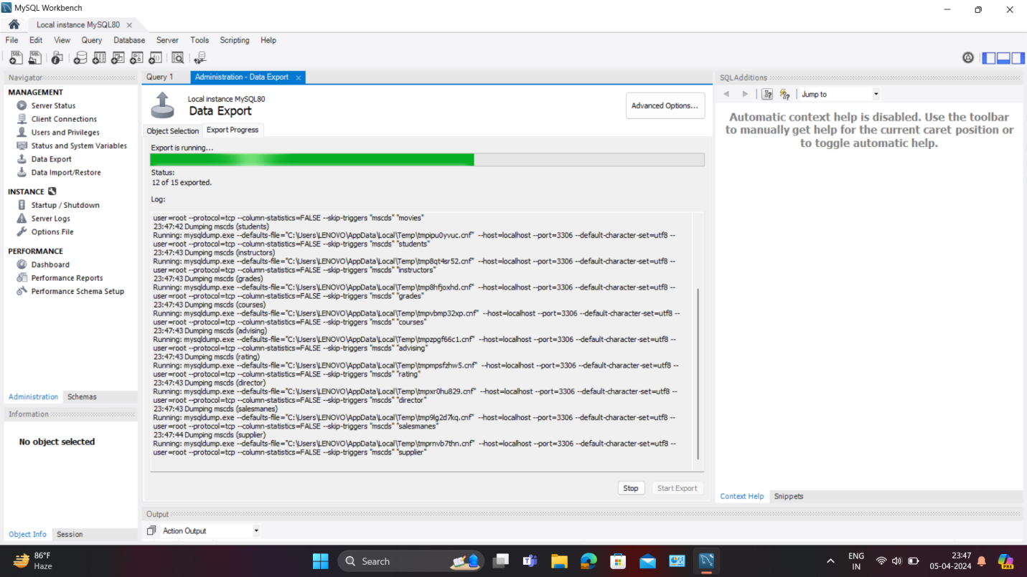

**When you click the Export button, a log of the export execution will be displayed, in which there will be a mysqldump command with the parameters specified in the interface.**

**2.Restore**

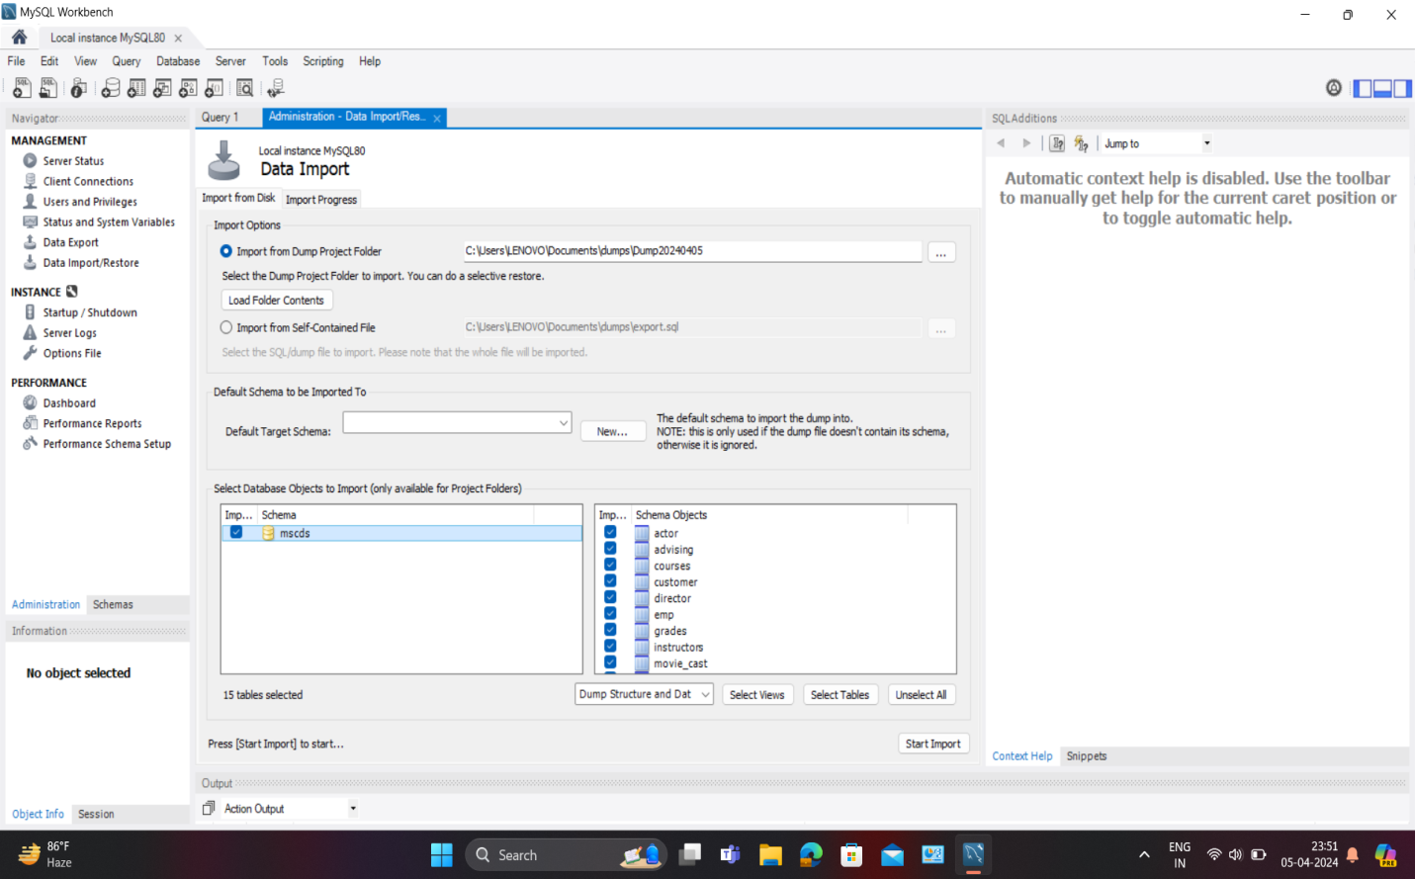

1. **Go to the Administration tab, on the Navigation panel (on the left by default)**
2. **Select Data Import\Restore**
3. **Select the source of the recovery Dump Project Folder or Self-Contained File, depending on what you selected at the backup stage**
4. **If you used a Dump Project Folder, then you can select the databases and tables that need to be restored.**
5. **If you use a Self-Contained File, then before restoring, you must select the schema into which you want to restore the dump. If you restore a dump to a server where the required schema does not exist, you can create it by clicking the New button.**
6. **Press the Start Import button.**